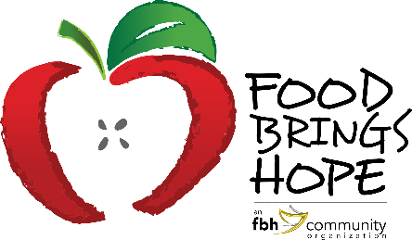
FOR IMMEDIATE RELEASE
Contact: Judi Winch, FBH Executive Director
386-317-5767
Judi@FoodBringsHope.org

FOOD BRINGS HOPE BACK TO SCHOOL FOOD AND SCHOOL SUPPLY DRIVE

Before school starts, Food Brings Hope wanted to ensure that the students in this community were prepared for the new school year. To do so, a food and school supply drive took place at Mainland High School on Thursday, August 12, 2021. Food Brings Hope provided 300 food and 300 school supply bags to families in need. The food bags consisted of non-perishable items, bread, pulled pork, and desserts. School supply bags contained the necessary items such as notebooks, pens, paper, and colored pencils. With the support of community donors, businesses like the MOSAIC, and organizations such as A WISH INC., Food Brings Hope was able to host another drive this year and fulfill the needs of many more students and their families.
In addition to providing food and school supplies, Food Brings Hope offered the opportunity for children 12 years and older, and their loved ones, to get vaccinated before going back to school. COVID-19 vaccines were administered by the Florida Department of Health in Volusia County in partnership with AdventHealth. A total of 18 individuals received their first dose of the COVID-19 vaccine. As an incentive for their willingness to stay protected, vaccinated recipients received a 10-pound ham from Food Brings Hope and a $10 food voucher from the Florida Department of Health.

Attached Photos:

About Food Brings Hope

Food Brings Hope (FBH) is an organization affiliated with a 501(c)(3) Public Charity named FBH Community, Inc. FBH provides collaborative solutions for families with children who experience hunger due to homelessness, poverty, or unfamiliarity with community resources. FBH’s mission is to Nurture the Mind, Body and Spirit of Underprivileged Children in our Community. Among other services, FBH offers school-based programs (termed KidsZone in elementary schools and TeenZone in the upper grades) that provides meals, tutoring and activities for at-risk students. FBH also facilitates enrichment activities such as Nutrition Days and Hands On banking programs, as well as field trips to local educational and cultural destinations and events. At FBH, 100% of all donations directly benefit the programs that support students in need.

For more information about Food Brings Hope, please visit www.FoodBringsHope.org or contact Judi Winch, Executive Director, Food Brings Hope at (386)843-1161 or Judi@FoodBringsHope.org

