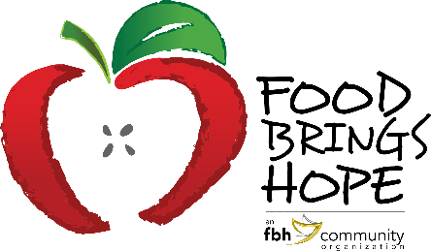
FOR IMMEDIATE RELEASE
Contact: Judi Winch, FBH Executive Director
386-317-5767
Judi@FoodBringsHope.org

FOOD BRINGS HOPE CHOSEN AS RECIPIENT OF IMPACT’S SEPTEMBER FOOD DRIVE

Food Brings Hope was the recent recipient of a food drive sponsored by IMPACT (Innovative Medical Professionals Assisting the Community of Today). IMPACT meets monthly to discuss their goal of making a difference in their community by exploring ways to give back. Each month they choose a local non-profit to support. Leighann Greco, Community Relations Director at Benton House of Port Orange, hosted a Donation Drive-by at Benton House, which allowed donors to drop off food items in a safe, socially distanced manner. Trilogy Health Services and Vitas Healthcare collaborated with Benton House for the food drive. To encourage participation, Benton House partnered with Fire House Subs to provide a box lunch to everyone who dropped off donations. During the entire month of September, these organizations collected non-perishable foods to donate to Food Brings Hope.
Judi Winch, FBH’s Executive Director, visited Benton House at the culmination of the fundraiser. She was overwhelmed with the generosity of IMPACT’s members.
Leighann Greco stated, “IMPACT has grown over the years, and we are thrilled that this allows us to donate to more non-profits such as Food Brings Hope.”
Attached Photos:
Picture #1 (from left) – Judi Winch, FBH Executive Director, Leighann Greco, Community Relations Director, Benton House of Port Orange, and Lisa Seale, Trilogy Healthcare.
Picture #2 (from left) – Lisa Seale, Trilogy Healthcare, Leighann Greco, Community Relations Director, Benton House of Port Orange, and Tyler Winch, FBH Volunteer.

About Food Brings Hope

Food Brings Hope (FBH) is an organization affiliated with a 501(c)(3) Public Charity named FBH Community, Inc. FBH provides collaborative solutions for families with children who experience hunger due to homelessness, poverty, or unfamiliarity with community resources. FBH’s mission is to Nurture the Mind, Body and Spirit of Underprivileged Children in our Community. Among other services, FBH offers school-based programs (termed KidsZone in elementary schools and TeenZone in the upper grades) that provides meals, tutoring and activities for at-risk students. FBH also facilitates enrichment activities such as Nutrition Days and Hands On banking programs, as well as field trips to local educational and cultural destinations and events. At FBH, 100% of all donations directly benefit the programs that support students in need.

For more information about Food Brings Hope, please visit www.FoodBringsHope.org or contact Judi Winch, Executive Director, Food Brings Hope at (386)843-1161 or Judi@FoodBringsHope.org

