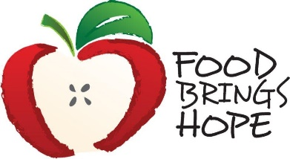
FOR IMMEDIATE RELEASE
Contact: Judi Winch, FBH Executive Director
386-317-5767
April 14, 2022
Judi@FoodBringsHope.org

FOOD BRINGS HOPE RECOGNIZES KIDDS ARE FIRST AS COMMUNITY PARTNER OF THE MONTH

Kidds Are First was chosen as Food Brings Hope’s February Community Partner of the Month. Rachel Arazashvili, Founder of K R Fashions and Kidds Are First, and her team of volunteers make families in need of clothing a priority.
Kidds Are First’s involvement with Food Brings Hope began by providing clothing to youth living in Hope House. Kidds Are First donated clothing and shoes to each resident, as well as, household items for the home. They ensured that residents received important items such as gowns for prom and special clothing for graduation. Along with sponsoring Hope House students, Kidds Are First supported the annual FBH Pierson program “Hope for the Holidays” celebration since it first began in 2016.
K R Fashions, a gently used clothing store, offers clients the unique experience of shopping for clothing in a store environment with no expense to themselves. It is no surprise that Rachel’s passion for helping the community has transpired into helping 50 local organizations including churches, hospitals, and other non-profits like Food Brings Hope. The future goal of Kidds Are First is to reopen their store in a new location sometime within the next few months.

ATTACHED PHOTO
Mamie Oatis, Community Operations Director and Rachel Arazashvili, Founder of K R Fashions and Kidds Are First.

About Food Brings Hope

Food Brings Hope (FBH), a 501(c)(3) Public Charity, provides collaborative solutions for families with children who experience hunger due to homelessness, poverty, or unfamiliarity with community resources. FBH’s mission is to Nurture the Mind, Body, and Spirit of Underprivileged Children in our Community. Among other services, FBH offers school based programs (termed KidsZone in elementary schools and TeenZone in the upper grades) that provides meals, tutoring and activities for at-risk students. FBH also facilitates enrichment activities such as Nutrition Days and Hands On banking programs, as well as field trips to local educational and cultural destinations and events. At FBH, 100% of all donations directly benefit the programs that support students in need.
For more information about Food Brings Hope, please visit FoodBringsHope.org or contact Judi Winch, Executive Director, Food Brings Hope at (386)843-1161 or Judi@FoodBringsHope.org

