FOR IMMEDIATE RELEASE
Contact: Judi Winch, Executive Director
Phone: (386) 843-1161
Email: Mary@FoodBringsHope.org

~ Premier Resorts & Management, Inc. and
COO, Samir Naran, Support Food Brings Hope ~

Dinners, catered by Harmony N Love, are provided for guests and the general public every Monday night at the Hampton Inn in DeLand, Florida. Manager Suzanne Akley donates a percentage of the dinner proceeds to support Food Brings Hope. Samir Naran, Premier Resorts Chief Operating Officer, matches the total funds collected each month. At a recent FBH board retreat, Mr. Naran presented Forough Hosseini, Founder and Chair of FBH, board member, Ed Noseworthy, and Executive Director, Judi Winch, with a generous $2,500 check.

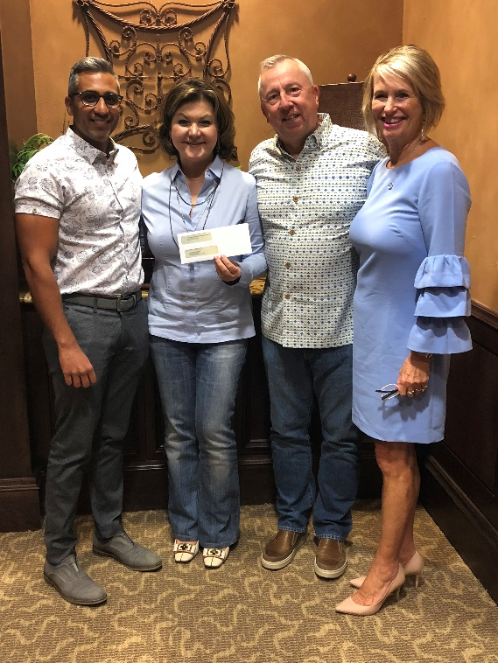

PICTURED (from left): Samir Naran, FBH Board Member, Forough Hosseini, Founder and Chairman of the Board of FBH, Ed Noseworthy, FBH Board Member, and Judi Winch, FBH Executive Director

About Food Brings Hope
Food Brings Hope (FBH), a 501(c)(3) Public Charity, provides collaborative solutions for families with children who experience hunger due to homelessness, poverty, or unfamiliarity with community resources. FBH’s mission is to nurture the mind, body and spirit of underprivileged children in our community. Among other services, FBH offers school based programs (termed KidsZone in elementary schools and TeenZone in the upper grades) that provide meals, tutoring and activities for at-risk students. FBH also facilitates enrichment activities such as Nutrition Days and Hands On Banking Programs along with field trips to local educational destinations and events. At FBH, 100% of all donations go directly to the programs that support students in need.

For more information about Food Brings Hope, please visit www.FoodBringsHope.org or contact Mary Habarth, Program Coordinator, at (386) 843-1161 or Mary@FoodBringsHope.org.

